
Controlling Robobuilder Humanoid robot using BASIC

If you want to give a gripper for your Robobuilder, order it now from my Shapeways shop at http://shapeways.com/shop/ip_robotics.
And don’t forget to order a servo from Robosavvy to go with it.

Edition 2
Index

Introduction 3
Getting Started 4
Variables, Lists, Numbers 6
Controlling program flow 7
Using Lists 8
Controlling Servos 12
Dynamic control of a servo 14
Accessing IO and sensors 15
Accessing the low level hardware 18
Sampling Sounds and FFT 20
Controlling the robot 22
Continuous forward walking 22
How it works 22
Basic auto-balance 23
How it works 23
Mirror moves 23
How it works 23
Dynamic distance sensor 24
How it works 24
Generating a walking gait 24
Access the Firmware 26
Modify RBC Serial Number 26
Evolving better solutions 27
Neural Networks 31
Using JBASIC pre-processor 34
Working with BASIC (remote) 35
A’mazing 37
Getting better output 39
Planning and execution 40
Building your own input line processing 43
Performance and Debugging 44
‘R’ – Trace option 44
‘I’ – Timed execution of single command 44
‘r’ – Timed execution 45
Concluding Remarks 46
Appendix A – Language Specification 47

Introduction
This document is a tutorial guide on programming a Robobuilder⁽¹⁾ series humanoid in Robot BASIC. This gives Robobuilder the ability to create simple actions in an elementary basic language. The software is /beta release.
BASIC.HEX is an Open Source firmware BASIC interpreter running on the Robobuilder RBC unit written in C. Its for any one who would like to try programming - but are daunted by the complexity of writing in C - and yet want more than Action builder, download and try it out !!
Writing your first program couldn't be easier, after downloading the firmware and uploading on to the robot using the RBC upgrade tool, connect a terminal program such as hyper terminal or putty and reset the power. See figure 1. There is also a BASIC pre-processor (in Java) to simplify the download of programs. See later chapter for more details
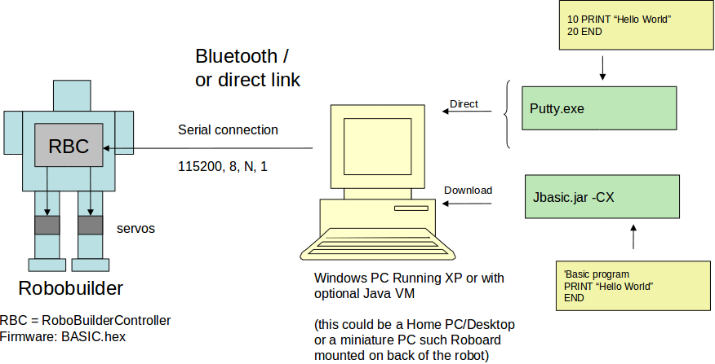
Figure 1
The firmware has 19 built-in motions to try out, including football kicks. Full access to all sensors, such as PSD, accelerometer and IR port. It’s fast enough to program in continuous walking and auto balance.

Getting Started
Download Basic.hex on to the RBC module using the RBCUpgrade tool as per Robobuilder manual pg 70. A windows OS build is available - basic.exe. it input/outputs using windows console. Robot hardware functions are stubbed out.
Turn on the RBC and connect a vt100 terminal emulator (such as HyperTerminal or Putty). You should see the following:
Basic v=$Revision: 375 $
Commands: i r l c z q
16 servos connected
0 lines in memory
:
At the prompt type one of the following
- i - input a new program at start of line will exit input mode
- r - run current program press Red button on IR remote
- R - run in TRACE mode
- l - list current program
- c - clear memory (C complete clear – setting flash to zeros)
- z - download files from PC
- q - check servos connected
- X – start charging (if plugged in)
- s – Make robot stand
- $ - Demo mode – responds to IR remote by playing built in motions
- o – turn sound sampling on – see lights on back
- d/D output the flash memory containing the program
- F dump firmware flash area (this is where the serial number is stored)
- V – print current version
In input mode you get a '>' prompt, in command mode a ':'. In input mode a command with a line number is stored in flash - and will be there after you turn the robot off.
When entering program lines, if no line number is input, then the command will be immediately executed. Otherwise the line is stored in FLASH memory on the controller and remains there even after the RBC is turned off. A line that starts with a full stop ‘.’ and contains no other characters will exit input mode, and the colon ‘:’ prompt is displayed. The program can be run by entering an ‘r’ or by pressing the red square button on the IR remote control.
In the following example a simple two line program is entered, the Hello World example. Code generated by the firmware on the terminal is in blue, and code entered by the coder is in green.

Here is an example session:
Basic v=$Revision: 236 $
Commands: i r l c z q
16 servos connected
0 lines in memory
: i
Enter Program '.' to Finish
> PRINT "hello world"
hello world
> 10 PRINT "hello world"
> .
1 lines entered, [25/3072] Bytes
: l
List Program
10 PRINT "hello world"
: i
Enter Program '.' to Finish
> 20 GOTO 10
> .
1 lines entered, [28/3072] Bytes
: l
List Program
10 PRINT "hello"
20 GOTO 10
: c
Clear Program
This program will get into a recurring loop, and if this happens in your programs (either accidentally or deliberately) then just press 'Esc' on the PC keyboard. The program will terminate immediately and return to colon prompt and command mode. If that fails then hit the 'OFF' button (on the robot!)
Notice in the above example each time you enter input mode its adds to the current program. If you want to start over then press “c”. To run the program press 'r' (and then Esc!)
Also the lines follow numerically so if you want to insert a line between 10 and 20, just enter a number between 10 and 20 i.e. 15, and the new code will be added between those lines. If you want to edit a line just key in its number and the newline will replace the existing line.
If the RBC fails to boot up properly a possible cause is incorrectly configured flash program space, this can be cleared if a prompt is available, but if not hold down both PF1 and PF2 as the robot boots and it will reinitialise (clearing any Basic program) the space.
Holding down PF2 on its own will put the RBC into charge mode – same as pressing 'X' at the command prompt.

Variables, Lists, Numbers
Variables
Only integer variables are allowed. Variables names are A-Z. Note the vairiables are NOT initialised at the start of each run – so you must do this at the beginning of your program for variables those that you use. This does mean that when a program has stopped you can look at the values of the variables by going to immediate mode and printing them out.
LET
Variables are assigned a value using the LET command. The variable is assigned the value of the expression on the right hand side of the equals “=” Eg:
LET A=5
LET C=A+2
Expression and Operators.
The right hand side can be any combination of variables, numbers and mathematical operators:
Maths + - * \ ( ) %
Comparison = < > <= >= <>
Logic & |
There is currently no operator precedence in BASIC and the evaluation is (unusually) right to left so for example 3*4+2 = 18 in that it evaluates 4+2=6 and then 3*6=18. If in doubt use brackets (see below).
PRINT
Print displays the value of any expression, so we can now write a simple program. The LET assigns the value of the expression to a variable, and the PRINT outputs to the terminal the result (along with a text message).
Enter Program '.' to Finish
> PRINT 5+3
8
> PRINT 5*(2+2)
20
PRINT can contain a list of things to print coma or semi-colon separated
10 LET A=(5+3)*(2+1)
20 PRINT "The answer is ";A
30 END

Controlling program flow
Simple loops

The simplest way to create a loop is using a GOTO statement followed by a line number. To create a conditional flow is the IF statement. It evaluates the expression and if true (i.e. evaluates to 1) will THEN jump to the line indicated, if false (evaluates to 0) it either continues to the next line or ELSE goes to the line indicated.
10 LET A=1
20 PRINT A
30 LET A=A+1
35 WAIT 500
40 IF A<10 THEN 20
50 END
This example loops printing the numbers 1-9 with a 0.5 second delay.

For/Next Loops

FOR-NEXT loops provide a simple way to execute a piece of a code a set number of times. In the example below the FOR loop initially set the variable A to 1 and then continues executing instructions until it reaches NEXT. At this point it checks to see if A has reached and if not increments A by 1 and jumps back to just after the FOR. If it has reached 5 it will continue to the next instruction after the NEXT. So the below code will print the numbers 1 through to 5.
10 FOR A=1 to 5
20 PRINT A
30 NEXT A
Generate random numbers
Also use % to get modulo of $RND - so example return 10 numbers between 0 and 5
10 FOR i=1 to 10
20 PRINT $RND % 6
30 NEXT I
Gosub and Return

GOSUB (a contraction of “GO SUBroutine” and RETURN provide a mechanism to have a common piece of code that can be called from multiple places. When the GOSUB is called it jumps to the line specified just like GOTO. But the difference is that the location it was called from is stored and when the RETURN is reached the code will jump pack to the line after the GOSUB.
10 PRINT "Hello";
20 GOSUB 50
30 PRINT " back";
40 END
50 PRINT " Here";
60 RETURN
Output:
Hello Here back

END
Program will stop if it reaches and END statement. It is not essential as there is a assumed END statement after the last line. Also you can have multiple END statements in a program if there are multiple exit points.

Using Lists
The standard variables A-Z are very important, but sometimes you need a list to create the code you need. In this Robot BASIC due to limitations on processor, there is just 1 list – the “current list” represent by !. There are a couple of other specialised lists (one for sound sample and one for Servo offset as well but these can'nt be accessed directly. In addition you can define a pointer to a list using LIST command. When this pointer is referenced it will first load its data into the ”current list”/ The maximum size of the current lit is 128. But it will dynamically vary depending on the last usage. So it current size is available in special variable $NE.

Simple LISTS

Although variables can contain only integer numbers, that number can be used as a pointer to a List. Lists are read-only and can contain numbers and expressions. lists are number from zero. First element is the length of the list
10 PRINT "List test"
20 LIST A=5,4,3,2,1,5
30 PRINT @a[1]
40 PRINT @a
3
4,3,2,1,5
In the code above the variable A will be set to point at the start of the list. When it access @A this automatically will evaluate the list and load its contents into the “current” !list so that they can be accessed by PRINT for example.

Index through a list

10 LIST A=5,65,66,67,68,69
20 FOR I=0 to 4
30 OUT @A[I]
40 NEXT I
50 PRINT
ABCDE
Dynamic lists

In this example the list contains an expression using variable ‘X’

5 LET X = 5
10 LIST A = 5,10+X,1,2,1,20-X
20 PRINT @A
30 MOVE @A,2,5
50 LET X = X+5
60 GOTO 20

Initialise current array

Rather !list can be loaded directly by the LIST command

LIST !=3,0,1,2

Inline List @{}

Or the !list can be initialised in-line with the code for example:

PRINT @{2,4,5}
MOVE @{5,10+X,1,2,1,20-X},2,5

Note the list is still evaluated as its loaded into !. This means list elements can contain variables and even special variables such as $X

Access current List
@!

Access offset list
@#

List arithmetic
@A-@B or @A+@B
73 PRINT @{2,4,5}+@{3,1,2,3}
74 PRINT @{3,1,2,3}+@{2,4,5}

LIST based Functions

$MAX, $IMAX, $MIN, $NORM, $SUM

10 LIST a=16,12,6,0,0,0,0,0,0,8,4,7,0,0,0,0,2
20 LIST b=16,13,0,0,0,0,5,8,0,8,1,0,7,0,0,8,0
30 PRINT $max(@a)
40 PRINT $min(@b)
60 PRINT $norm(@a-@b)
70 SORT @a

$MAX return the value of the largest element. Also the function $IMAX returns the index of the largest element. You can also sort a list using SORT command

Access parts of a list

PRINT @{5,1,2,3,4,5}[2,3]
PRINT @{5,1,2,3,4,5}[2,7]

Sub list [a,b] creates a new current list from element a through to b. If b is passed end of list, end is assumed and a<b and a>=0.

Pattern matching using Hamming distance

PRINT $HAM(0,@{3,1,2,3},@{3,3,2,1}

Comparing two lists, each element that matches scores one, each miss nothing. So 1,2,3 matches with 1,2,3 to score ‘3’ but matches with 3,2,1 only ‘1’ (the two).

DATA commands

DATA is very similar and very different to a LIST. Its used in the same way. But there are two BIG differences. Firstly it doesn’t start with the length of the list and the numbers in the list must all be byte values (i.e. 0-255). It’s stored in FLASH as numbers and so is much more efficient. A LIST is evaluated each time its used. But a DATA is set of constants. Its meant for storing large arrays of numbers such as a set of servo values.

10 DATA a=12,6,0,0,0,0,0,0,8,4,7,0,0,0,0,2
20 PRINT $max(@a)

SET & INSERT

SET I,V
set/insert into current array i.e. ![I]=V
Inserts element V before I so ...
INSERT 0,V adds v to start of array
INSERT $NE,V adds to end of array

SELECT & DELETE

DELETE 5 delete single element
DELETE * delete all - i.e. No elements in current array
DELETE 5,7 delete all elements between values (inclusive)

Assuming array initialised to 0,1,2,3,4,5
DELETE 3,5
0,1,2

DELETE 5,* delete from ![5] to end of array
DELETE 3,*
0,1,2

Using to record and play back moves
The power of lists come when they are used to store captured information. For example using the ability to insert into the array creates a first-in first-out list for recording and play back of servo values straight forward.

Initialise:
delete *
i=0

Recording:
a=$servo(13)
b=$servo(14)
c=$servo(15)
insert i,a

i=i+1
insert i,b
i=i+1
insert i,c
i=i+1

Playback:
a=@![i]
b=@![i+1]
c=@![i+2]

servo 13=a
servo 14=b
servo 15=c
i=i+3

Printing arrays

An array can be printed by specifying the array, in addition a dimensional paramter 'n' can be added to improve readability. i.e PRINT @!{}:n

> PRINT @{6,0,1,2,3,4,5}
> PRINT @!:2
0,1
2,3
4,5

Stand array
$STAND(16)

> PRINT $STAND(16)
125,179,199,88,108,126,72,49,163,141,51,47,49,199,205,205

Zeros

Initialise the !list with zeros
> PRINT $ZEROS(5)
0,0,0,0,0

Generating an array of random numbers

$RND(a,b,c) This will generate an array of 'a' randoms numbers whos values will range between b and c i.e.

> PRINT $RND(6,1,6)
4,2,3,1,4,1

Controlling Servos
Take up basic pose

Couldn’t be easier, this for Huno configured 16 servo bots. For those with a Hip kit and 18 or more servos use STAND 16.
10 STAND 16
There’s also a MOVE command for customised poses.
10 MOVE @{16,125,179,199,88,108,126,72,49,163,141,51,47,49,199,205,205},10,1000
The move command takes a list of servo value and two additional parameters, the number of steps to take and the time to get there. So in the above example the robot will move from its current position to the new one specified in the array in 10 steps over 1000ms or 1s. Thus each step will take 100ms. If a servo is at position 100 and the move specified 200, then in each 100ms step the servo will be incremented by 10 from (200-100)/10.

The servo speed can be set using the SPEED command. Also the division in step doesn't need to be linear i.e. equal steps of 10 but other types of change can be set by MTYPE.

The shortest duration of any one step is 25ms thus a request of 10 step over 50ms will actually result in 10 steps each of 25ms so a total duration of 250ms not 50ms. The driving calculation is the number of steps not the duration.

Alternative shows use of the MOVE command with a literal/in-line LIST to take up Basic pose. Note: There is one subtle difference with STAND in that its not affected by the OFFSET command where as MOVE is.

Run a built in motions

There are 19 built in motions that can be access directly using the RUN command. See Appendix A for list of built in motions
10 STAND 16
20 RUN $MAPIR($IR)
30 GOTO 20
Read and set servo
This reads current position of servo 12 and then moves and extra 5
10 LET a=$servo(12)
20 PRINT "Pos=";a
30 SERVO 12=a+5

Use of Passive mode

The SERVO can be put in Passive Mode. In this mode it will turn freely. This means that you can then use read positions to determine how its been changed. So in the code below SERVO 12 is first put in passive mode and then its actual position is read every 0.5 second out printed out. Servo 12 is the top right hand servo on the Huno layout.
10 SERVO 12=@
20 PRINT "Servo 12 = "; $SERVO(12)
30 WAIT 500
40 GOTO 20
Changing Red/Blue IO port values

The servo have a digital IO which is connected on the transparent servos to RED and BLUE LEDs. To set the IO value and thus switch the LEDs on use the “~” parameter on the SERVO command. This then rather than setting the position of the servo to the value in A will set the IO. Only the last two bits i.e. 0,1,2,3 have any affect.
10 LET A=0
20 SERVO 12=~A
25 WAIT 50
30 LET A=A+1
40 GOTO 20
Output: Servo 12 will flash red/blue light (assuming its a transparent servo!)

Dynamic control of a servo
The Robobuilder humanoid robot can be extended with up to 32 servos (from the standard basic kit of 16). One way of extending is to add some form of gripper to enable the robot to pick up objects in its world. A simple gripper can be built in many ways; one way is to use a 3D printed object such as is available from Shapeways.Com. Here is an example of a couple available from Ipswich Robotics : Left gripper or Right gripper

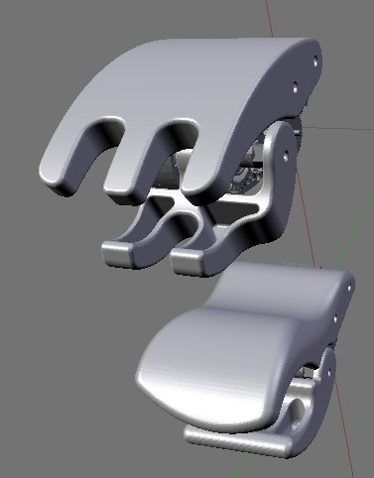
Top – New style gripper, Bottom original style

10 STEP 18=70,120,5
Assuming a gripper is connected to Servo 18 this function will slowly close the gripper until it either is fully closed or its movement is stopped by an object in it grasp.
In the above example the code will attempt to STEP the value of the servo from position 70 to position 120 in increments of 5. However unlike a MOVE command it tests each move to see if the servo has actually moved. Thus if an obstacle stops this (such as an item placed in the gripper) the STEP will stop. By varying the increment value will alter the speed of stepping but also how hard the grips.

Accessing IO and sensors
Read from console and IR port
10 LET A=$KBD
20 PRINT A
30 LET A=$IR
40 PRINT A
50 GOTO 10
Read IR button pressed

The remote control can be accessed using $IR register. It will wait until the remote is pressed and then return a value between 0-63 representing the button pressed. So for example ‘A’ is 1, ‘B’ is 2, ‘[]’ is 7.
10 LET A=$IR
20 PRINT "Received=";A

Show PSD using Lights as a proximity detector
10 LET P=$PSD
20 LIGHTS P-10
30 GOTO 10
The Position Sensor is accessed via special variable $PSD and (assuming installed on the robot) will return a value between 10-50 representing the distance in cm to the object in front of the sensor. Beyond that distance only 50 is returned and nearer than 10 only returns 10. If no PSD is connected the result is indeterminate.

The lights on the back of the Robot (Run,Pwr, Err) can act as a bar graph showing how close an object is to PSD sensor using the following simple code.

Show PSD sensor output as a bar on terminal
10 OUT 45,$psd
20 OUT 42
30 PRINT
40 GOTO 10
Outputs the ASCII value '-' 45, followed by '*' 42, I.e ---------*

GET - reads a line into current array

> GET
123456
> PRINT @!
49,50,51,52,53,54

Checking both console and IR port

10 IF $KIR<0 THEN 10

This will wait until either is pressed which is fine if you don't need the value. Better to do this

10 LET K=$KIR
20 IF K<0 THEN 10
30 /// see what value K is set to

Reading battery level

$VOLT will return the voltage in mV of the battery. If the battery level is above upper limit (9.65v) this means the robot is actually plugged into the power supply and so can be used to determine if charging is possible. If its below lower limit of 8.1v this means its essential flat and about to fail.

const ulimit 9650
const mlimit 8600
const llimit 8100

v=$volt
print v;"mV Detected"

if v>ulimit then
print "Plugged In"
endif

if v<llimit then
print "Low battery"
endif

You can also easily convert the voltage into a %charge figure

if v>mlimit then
p=(10*(v-mlimit))/(ulimit-mlimit)
p=50+5*p
else
p=(10*(v-llimit))/(mlimit-llimit)
p=5*p
endif

The mid point is actually the mid point between the upper and lower limts hence the slight extra complication in converting to a % charge.

Read accelerometer values

The following example shows access to the accelerometer via special registers X, Y & Z. You can also access a millisecond clock (up dated by the heart beat) as $TICK
10 PRINT $TICK;" X=";$X;" Y=";$Y;" Z=";$Z
20 WAIT 500
30 GOTO 10
By knowing the X, Y and Z values the orientation of the robot can be determined. Here some simple pseudo-code :

'face down (z<-50)
IF $z<-50 THEN
PRINT "FACE DOWN"
ENDIF

'face up (z>50)
IF $z>50 THEN
PRINT "FACE UP"
ENDIF

'upright (y>50)
IF $y>50 THEN
PRINT "UPRIGHT"
ENDIF

Accessing the low level hardware
RBC unit I/O ports

Port/Pin | I/O | Description
PC7 | O | Power LED (Red)
PG2 | O | Power LED (Green)
PA7 | O | Error LED (Red)
PA6 | O | Run LED (Green)
PA5 | O | Run LED (Blue)
PA4 | O | PF2 LED (Orange)
PA3 | O | PF1 LED (Red)
PA2 | O | PF1 LED (Blue)
PA1 | I | PF2 Switch (High : Not pressed, Low : Pressed)
PA0 | I | PF1 Switch (High : Not pressed, Low : Pressed)

Reading PF1 and PF2
The buttons on the back of the RBC are normally logic high and go low when pressed. The are access via bits 0 &1 on PORTA -
10 PRINT "Press PF1 or PF2 to start"
20 IF ($port:a:0=1)&($port:a:1=2) THEN 20
30 PRINT "Done"
Note the use of the & for logic AND.
Switch LEDS on and OFF
The LEDs can be access via the PORT as well. Red Power LED is on Port C bit 7. This LED is on when bit is zero and off when bit is 1. So the following will flash the light
10 LIGHTS 0
20 PUT port:c:7=1
30 WAIT 500
40 PUT port:c:7=0
50 WAIT 500
60 GOTO 20
I2C Communication example(s)
This example reads values from the optional accelerometer (address 112). The bytes are available from current array @![n]. Note use of $CVB2I() - converts the read bytes values to integers i.e. 255 -> -1.
10 FOR I=1 to 10
20 I2CO 112,@{1,2}
30 I2CI 113,6
40 PRINT "X=";$CVB2I(@![1]);" Y=";$CVB2I(@![3]);" Z=";$CVB2I(@![5])
50 WAIT 250
60 NEXT I
output:
X=5 Y=-2 Z=6
X=5 Y=-2 Z=7
…
Direct read and writes to wck BUS.
A special flag on the PRINT command – the '#' at the start tells BASIC to print not to the serial port but to the wck Bus. This enable BASIC to access any wck Command directly. There are two variants – either as string or as an array. The response returned in @![0] && @![1]. See below.

PRINT #{4,255,0,0,0}
PRINT #”FFA00020”

> PRINT #@{4,255,160,0,32}

> PRINT @!

0,125

Sampling Sounds and FFT
Sampling
The Microphone can be sampled into a LIST @< and processed including being converted into a spectrum using FFT command.
SAMPLE 5,5000,4,64
This loads a 64 element sample (Maximum size) into the area, but only if the audio level gets above ‘5’ with in the next 5000 ms (i.e. 5sec). Each sample is 4ms long.

The sample can be displayed by PRINTing the current list @!

Here’s an actual sampling

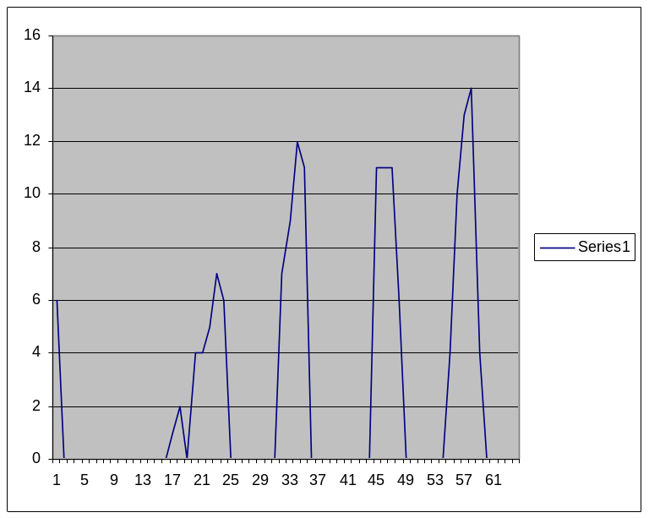

@{64,6,0,0,0,0,0,0,0,0,0,0,0,0,0,0,0,1,2,0,4,4,5,7,6,0,0,0,0,0,0,0,7,9,12,11,0,0,0,0,0,0,0,0,0,11,11,11,6,0,0,0,0,0,0,4,10,13,14,4,0,0,0,0,0}
FFT
Fast fourier transform converts time sample data into a frequency spectrum. Here is a test case where FFT is done on a single impulse. It will contain every frequency of equal amount.
FFT @{8,100,0,0,0,0,0,0,0},1
FFT from an actual speech sample
Result:
173,55,45,20,9,109,102,28,45,11,39,63,22,16,19,2,14,23,5,18,12,7,11,16,14,19,17,8,7,10,17,10,5,9,16,12,7,9,17,21,13,16,12,6,13,19,5,24,14,3,17,14,22,64,40,11,47,28,99,107,9,20,45,57
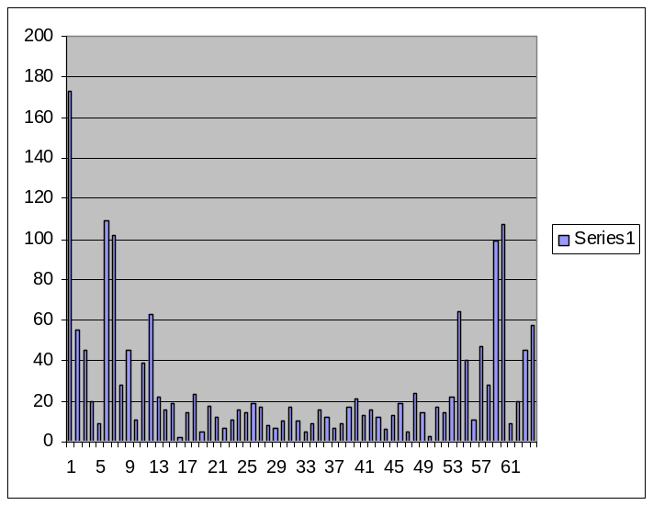

Notice firstly there is a big DC element and that the result is a mirror image about the centre is because the max freq is half the sampling frequency. So 4ms sample – maximum frequency is 250Hz. So each element of the array represents 250/32 Hz or 8Hz per sample. The two peaks being at 5 or 40Hz and 11 or 88Hz,

Access the elements
FFT @{8,0,10000,0,0,0,0,0,0}
FOR I=0 to 7
PRINT @![i]
NEXT I
Putting it into a program
10 PRINT "LISTEN"
20 SAMPLE 5,5000,4,64
24 IF $NE=0 then 60
30 FFT @!,1000
35 print @![1,31]
40 print "Pk=";$MAX(@!);" Hz=";$IMAX(@!)*8+8
50 goto 10
60 end
Selecting a specific frequency
Assuming we want to identify the amplitude of the frequency at 40Hz which corresponds to cell 5 (see above_) we can access using @![5] as the data is stored in the !list. This value could then be used to trigger a specific action or event on the robot – such as a dance move.

Controlling the robot

Continuous forward walking
5 STAND 16
10 PRINT "press any key start"
15 LET K=$kbd
20 LET A=25
30 PRINT "R";
35 MOVE @{16,123,156,212,80,108,126,73,40,150,141,68,44,40,138,208,195},1,A
40 MOVE @{16,130,165,201,81,115,134,81,31,147,149,72,44,40,145,209,201},1,A
45 MOVE @{16,132,171,197,83,117,137,86,28,148,152,78,43,41,154,209,206},1,A
50 MOVE @{16,132,175,195,87,117,139,91,27,152,154,87,43,43,164,209,211},1,A
55 MOVE @{16,132,178,197,91,117,137,95,28,157,152,97,43,48,172,209,213},1,A
60 MOVE @{16,130,179,201,95,115,134,96,31,161,149,105,43,53,179,210,214},1,A
65 MOVE @{16,127,178,206,98,112,130,95,35,166,145,111,42,57,182,210,214},1,A
70 MOVE @{16,124,175,212,100,109,127,92,40,170,142,113,42,59,183,210,214},1,A
75 PRINT "L";
80 MOVE @{16,124,175,212,100,109,127,92,40,170,142,113,42,59,183,210,214},1,A
85 MOVE @{16,120,172,217,102,105,123,88,46,170,138,111,42,57,182,210,214},1,A
90 MOVE @{16,116,167,221,103,101,120,83,51,169,135,106,43,53,179,210,214},1,A
95 MOVE @{16,113,162,224,102,98,118,77,55,167,133,97,43,48,173,209,213},1,A
100 MOVE @{16,111,157,225,98,96,118,73,57,163,133,87,43,43,164,209,211},1,A
105 MOVE @{16,113,153,224,93,98,118,70,55,159,133,79,43,41,154,209,206},1,A
110 MOVE @{16,116,152,221,89,101,120,69,51,155,135,72,44,40,146,209,201},1,A
115 MOVE @{16,120,153,217,84,105,123,70,46,152,138,69,44,40,140,208,197},1,A
120 MOVE @{16,123,156,212,80,108,126,73,40,150,141,68,44,40,138,208,195},1,A
125 GOTO 30

How it works
Line 5 STAND - instructs the robot to take up basic posture. line 15 causes the program to wait for a key press - you could alternatively make it wait for IR remote by switch $KBD for $IR.
Line 35 move @{...},1,A moves servos from their current position to the new position, as specified in the list @{...}. First number is length of list i.e. 16. There are two other parameters, the '1' is the number of increments to take and the 'A' is a variable containing 25, the total length of time i.e. 25ms. You can vary A or switch for a constant etc...
Line 125 GOTO will cause the program to loop for ever (or until 'Esc' is pressed on keyboard). Line 25 and 70 produce 'RLRL... etc on the serial port.
To run type 'r'. in command mode ':' prompt or the red square on IR. The program is in flash so its still there even after being turned off. Just turn back on and press the red button ! (you'll need to switch the KBD for IR first - or it after standing it will wait for keyboard input)
Lots of mods to expand this are possible. The program could check for $PSD value or check, or see if its fallen over, by testing the accelerometer $X / $Y or $Z. You can vary the speed by changing the value 'A' -etc ...

Basic auto-balance
10 STAND 16
20 Print "Press any key"
30 if $kir<0 then 30
40 list m=7,-4,-2,-1,0,1,2,4
50 Let d=$find($z, @{7,-15,-10,-5,0,5,10,15}
60 let o=@m[d]
70 wait 10
80 print $z;"-";d;"-";o
90 servo 10=$servo(10)+o
100 servo 13=$servo(13)-o
110 wait 10
120 if $kir<0 then 40

How it works
Line 10 causes the robot takes up Basic pose. Line 30 make it wait until keyboard or IR input. Line 40 set up list of offset values. Lines 50 maps the output of the z axis of the accelerometer ($z) to a range using the $find function. Line 60 then translates that into a displacement to apply to the servo. In lines 90 and 100 it updates the current position of the servo $servo(x) with the offset o. Line 120 cause the program to loop until either keyboard or IR remote is pressed ($kir) is received. If -1 it means no input.

Mirror moves
Run the program and then move the right arm - and watch the left arm follow!
5 stand 16
10 servo 13=@
20 servo 14=@
30 servo 15=@
40 print "ready"
50 if $kir<0 then 50
60 let a=$servo(13)
70 let b=$servo(14)
80 let c=$servo(15)
90 servo 10=254-a
100 servo 11=254-b
110 servo 12=254-c
120 wait 50
130 goto 60

How it works
The program first lines 10-30 puts servos 13,14,15 into passive mode, this makes them free to move. These servos form the right arm of the robot. It then loops reading their current position on line 60-80. Its then moves the left arm by corresponding amount. Because the left arm servos are reverse they move in the opposite direction, hence the 254-a.

Dynamic distance sensor
The arms dynamically move as the distance sensor detects your presence !!
10 stand 16
20 servo 13=200
30 servo 10=50
40 let a=$psd
45 print "Psd=";$PSD
50 servo 13=250-a
60 servo 10=a
70 wait 200
80 goto 40

How it works
The value of the PSD sensor (always between 10 and 50) is used to set the position of servo 10 and 13 (the shoulders). These will move in unison based on the value. If nothing in range PSD will return 50, so servo 13 is set at 200 and servo 10=50, whilst at closet approach PSD will be 10 and Servo 13=240 and servo 10=10.

Generating a walking gait
In one of the examples above I show continuous walking by sending out a sequence of predefined servo moves. But its possible to generate a walking gate mathematically using sine waves. The position of each servo can be defined as
Position = Offset + Amplitude * SIN (angle + phase)
As the angle goes through 360 degrees the servo position will vary about the offset by +/- the amplitude during each walking cycle.
To program this in BASIC needs the function $SIN(angle) will returns a sine value between -32768 and +32768 for angle values between 0 and 255. So to use the I create the following code:
FOR X=0 to 15
LET P = B + (A*$SIN((X + C)*16)/32)/1024
NEXT X
P = Position
X = Angle (0->15)
A = amplitude
B = offset
C = phase (0->15)
To enable each servo to have a different value of A, B and C I put those values into three indexed lists as follows
LIST A=16, 10, 13, 15,11, 10, 10,13,15, 11, 10,22, 1, 9, 22, 1, 9
LIST B=16,122,166,210,92,107,129,83,42,159,144,91,43,50,161,209,205
LIST C=16, 0, 2, 8, 5, 0, 15, 2, 8, 6, 15, 5,11, 5, 5, 5, 5
A contains a 16 element list containing the amplitudes of the sine waves. To access a list element use @A[Y] where Y is a value between 0 and 15. @A[0] will point to the value 10 (not 16 which is just the length and not stored).
So putting this all together the following code will generate a continuous walking motion:
5 LIST A=16, 10, 13, 15,11, 10, 10,13,15, 11, 10,22, 1, 9, 22, 1, 9
10 LIST B=16,122,166,210,92,107,129,83,42,159,144,91,43,50,161,209,205
15 LIST C=16, 0, 2, 8, 5, 0, 15, 2, 8, 6, 15, 5,11, 5, 5, 5, 5
20 FOR X=0 TO 15
25 FOR Y=0 TO 15
30 LET P=(X+@C[y])*16
35 LET P=$SIN(P)/32
40 LET P=(@A[Y]*P)/1024
45 LET P=@B[Y]+P
50 PRINT P;":";
55 SERVO y=p
60 NEXT Y
65 PRINT ""
70 NEXT X
75 IF $KIR<0 THEN 20
The lines 30-45 breaks the calculation into simpler steps as BASIC unfortunately crashes with long expression due to shortage of memory. The calculation is sent to the servo in line 55. The program is fast enough to run a smooth walking gate. It will continue to run until it detects IR or keyboard press (or you turn it off!)

Access the Firmware

Modify RBC Serial Number
Some times the firmware can get corrupted and the serial number is lost. When this happens the standard firmware won't download programs from the internet as they won't match the serial number. So to inspect the firmware you need to read the Flash memory using the $ROM() function. Type 'i' and enter the following program:
10 FOR I=1 to 13
20 OUT $ROM(I);
30 NEXT I
40 PRINT
If you see 13 digits all is well. If not find your serial number (its printed on the RBC unit) and update the ROM from interactive /input mode using for example:
POKE 1,48
POKE 2,49
etc ...
This will set the first digit to ASCII 48 or '0', second to '1' etc ... (Sorry you will have to covert your s/n to ASCII yourself - hint is 48 + digit 0-9?
Use this with CAUTION !!!!!
Basic programs are stored in flash - it will overwrite any action or motion scripts you have created. If / when you revert to standard firmware you will need to reload them.
It is possible (hopefully unlikely) that if the firmware goes wildly wrong it could overwrite your serial number and/or zero positions - these are recoverable but with some effort (see above)

Evolving better solutions
All the built in motions are predefined, stored in ROM, and played out using commands such as MOVE. So for instance to make the robot stand up one can issue the MOVE $STAND(16),10,1000. This moves the robot from its current position to the new position specified by the array $STAND(16) in 10 steps taking 1000ms or 1 sec. The positions have been predefined for an ideal robot on a flat surface - but what if they are not right for the current situation, if the surface is uneven, or the robot misaligned, what we need is to able improve the positions with a more dynamic set, that take into account the current environment. This section looks at one technique for doing that.

Imagine an "organism" containing a single "chromosome" represent by a list of 6 numbers; 1,1,1,1,1,1 Each number represents a "gene" and in turn the gene controls a servo or some other output. A genetic algorithm will attempt to find the best set of genes that produce the ideal output.

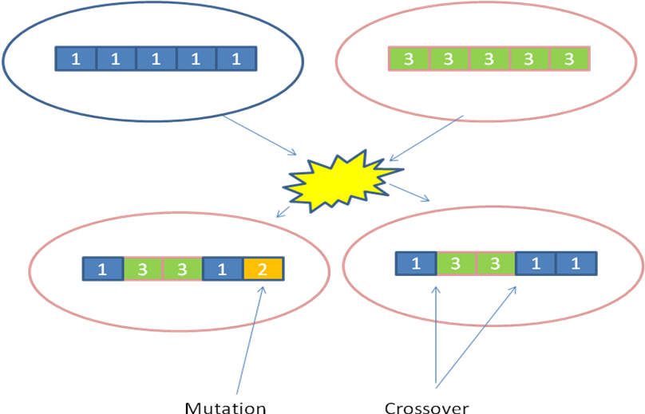

GA's are a simple mechanism to use and requires the following steps:
1. Initialise
2. Reproduction
3. Select
4. Repeat from step 2

Taking each step in turn..

1. Initialise
We need to create "Adam" and "Eve". This is simply to set up the initial arrays. This could be set to random values or perhaps a known "close" position to ideal. So lets create two "organisms" represented by "chromosomes"

i.e.
> PRINT @{12,1,1,1,1,1,1,3,3,3,3,3,3}:6
1,1,1,1,1,1 <-- Adam
3,3,3,3,3,3 <- Eve

2. Reproduction
The aim here is to create new "organisms", arrays of numbers, that are a combination of the "genes" from the "parent" array(s). To do this is a new command "GEN". It takes six parameters:

GEN A,B,C,D,E,F,G
A=number of generations to build
B=length of "chromosome"
C=mutation rate (%) 0-100
D=mutation range n - values will vary by +/-n
E=Min Val v1
F=max val v2 (where v2>v1)
G=type [0,1,2] Number of crossovers (0=>single parent)

2.2 Sexual
2.2.1 Single or Double CrossOver

With two "parent" organisms we can "mate" them by generating new "organisms" that are a combination of genes from the "parents". So with one cross over point you get all the genes from A up to CO and then all the genes from E

i.e.
A: 1 1 1 1 1 1
E: 3 3 3 3 3 3

Crossover |
V
O: 1 1 1 3 3 3

With two Cross overs you can get far more complexity

Crossover |
V
O: 1 1 1 3 3 1
^
Crossover |

So lets now use "GEN" to generate offspring.
> GEN 8,6,0,0,0,5,2 <-Generate 8 off spring of length 6 parent type 2
> PRINT @!:6
1,3,3,3,1,1 <-offspring 1 CO1 @ 1 & CO2 @ 4
1,3,3,1,1,1 <-offspring 2 CO1 @ 1 & CO2 @ 3
1,3,3,1,1,1 <-offspring 3 CO1 @ 1 & CO2 @ 3
1,1,3,3,3,1 <-offspring 4 CO1 @ 2 & CO2 @ 5
1,1,1,3,3,1 <-offspring 5 CO1 @ 3 & CO2 @ 5
1,3,3,3,1,1 <-offspring 6 CO1 @ 1 & CO2 @ 4
1,3,1,1,1,1 <-offspring 7 CO1 @ 1 & CO2 @ 2
1,1,1,1,1,1 <-offspring 8 CO1 @ 6 & CO2 @ 6

Notice no mutation is involved and yet most of the off-spring have a completely different chromosome from its parents.

2.2.3 Mutation

The problem with the above is that it can only create an output containing 1 & 3s. Ii can never produce a chromosome containing 1,2,3,1,1,1. The '2' gene is a mutation. We can add mutation into the generation of offspring

With the same initialisation above but now using type 0 i.e. no cross over, 1 parent (first in list - 1,1,1,1,1,1)
This has 25% mutation rate (per gene) with a maximum variation of +/- 4 (whilst still being in permitted range). A gene outside range could be considered non-viable

> GEN 4,6,25,4,0,5,0
> PRINT @!:6
1,1,1,2,1,1
1,3,1,0,4,1
1,4,1,1,1,1
1,1,1,1,1,0

Note this example was purely asexual reproduction only Adam was used and all the off-spring are pure mutations.

3. Selection
1. Fitness factors

Selecting the fitness factor and calculating it is the hard bit.

Lets say our ideal organism has a chromosome that look like this 1,2,3,4,5,6. We could have a fitness factor calculated by a Score 5 points for number in correct position and -2 points for every number out of position

1,1,2,2,3,3 = +5,-2,-2,-2,-2,-2 = -5
1,2,2,2,3,3 = +5,+5,-2,-2,-2,-2 = +2

Example code

for m=0 to 5 'for each "gene" (6 genes in chromo)
t=(l*6)+m
if @![t]=(m+1) then 'if they match i.e. @![0]=1 or @![2]=3
s=s+5 'score +5
else 'else
s=s-2 'score -2
endif
next m

To save this result we add to the end of the list using INSERT $NE,S where S is the score. having scored each organism we now need to select one or two to create the next generation. This is done by sorting the population (in this example 8 organisms) so the fittest are at the beginning of the list array

2. SORTing wheat from Chaff

SORT #a,b,c 'Length of gen, no of generation, no to survive

Assuming we have three organisms A,B,C which we have calculated fitness of each and found to be 1, 5 and 2 respectively

A = 1,1,1 fitness=1
B = 2,2,2 fitness=5
C = 3,3,3 fitness=2

1,1,1,2,2,2,3,3,3,1,5,2 as a list

I want to sort this list so te best one or two are at the start (ready to generate the next population and this is where SORT comes in.
We have 3 organisms each has 3 genes in its chromosome and we want the top organism.

SORT #3,3,1 => 2,2,2

A Example picking 1-6 in order

probability of having a chromosome of 1,2,3,4,5,6 is 6^6 or 46,656

B. Example using Standing position

Lets have a 16 gene chromosome where gene[0] controls the absolute position of servo(0)

DATA v=125,179,199,88,108,126,72,49,163,141,51,47,49,199,205,205
move @v,10,1000 'initialise Adam and stand up

Selection will be based on how well balanced the robot is by attempting to minimise X & Z accelerometer values. Tip here is after the move it take the robot time to settle before we can test fitness.

loop:
generate population (16 genes)

for each organism
move to "chromosome"
wait delay
wait for XZ to stabilise
store fitness factor -((x*x)+(z*z))
next

sort and select fittest organism
GOTO loop

closer X & Z are to zero the bigger the fitness factor i,e, X=2 and Z=3 becomes a score of -(2*2+3*3) = -13 where as X=-1 and Z=1 then score = -(-1*-1 + 1*1) = -2

Neural Networks
Creating a neural network controlled robot is one of the holy grails of robotics. All living animals are controlled by neural networks, collections of special cells that can respond to stimuli and produce "intelligent" behaviour. So mimicking this in software for a robot could potentially achieve similar type of behaviour.

A neuron (or strictly an artificial neuron) is a simple function:

Output = F(Sum(Inputs * Weights) - Threshold)

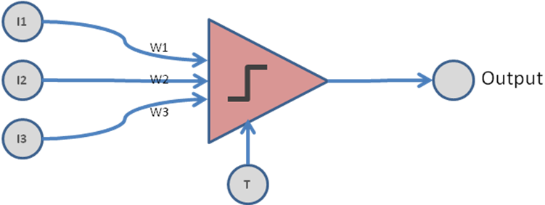

10) I1 --3--:\
5) I2 --2--: \___ O1
-2) I3 --4--: /
1) T-1--:/

This is a 3 input neuron. with One output and threshold of T. Each input on a neuron has a "weight" associated with it. so W1 on I1, W2 on I2, W3 on I2 and a W4 on the threshold. So to calculate neurons value we first sum the inputs* weights.

So O1 = F(10*3 + 5*2 + -2*4 - 1*1) = F(31)

F is function that now determines whether 31 is enough to trigger the neuron or not. So the neurons output could be either 0 for inactive or 1 for active (these are perceptrons in AI parlance). So we could say

O1 = 1 if F>=0
O1 = 0 if F<0

So assuming this function for F since 31>0 then O1=1. The neural network can be specified as a set of numbers Inputs,Outputs, Weights in the current array:

In the above example the values are:
I1 I2 I2 O1 W1 W2 W3 T
10,5,-2, 0, 3, 2, 4, 1

Notice O1 is left at '0' waiting for the output to be calculated, and the threshold appears as the last weight.

Now we can use the NETWORK function to calculate the output in one go.

Command is NETWORK [no inputs],[no outputs],[Type],[nn ly1],[nn ly2],[nl3]

Type : 0 No change
1 if v>0 => 10 else 0
2 if v>0 => 10 else -10
3 if v>0 => 1 else 0
4 => 256/(1-e^(x/4))

> PRINT @{8,10,5,-2,0,3,2,4,1} ' set up array
' Evaluate Network 2 inputs, 1 output, type 3
' 1 Node in Layer 1
' 0 Node in Layer 2
' 0 Node in Layer 3

> NETWORK 3,1,3,1,0,0

> PRINT @!
10,5,-2,31,3,2,4,1

set 0,$x ' <- Set Input 1 (@![0]) = X accelerometer value
set 1,$z ' <- Set Input 2 (@![1]) = Z accelerometer value
network 2,1,4,2,0,1
print "out=";@![2] ' <- Show output of Network

Evolving the network

Since neural network can be defined as set of weights - we can evolve these until the output matches our desired output. There are lots of different techniques to do this but the simplest is to use our GA mechanism to evolve a better set of weights

The XOR problem

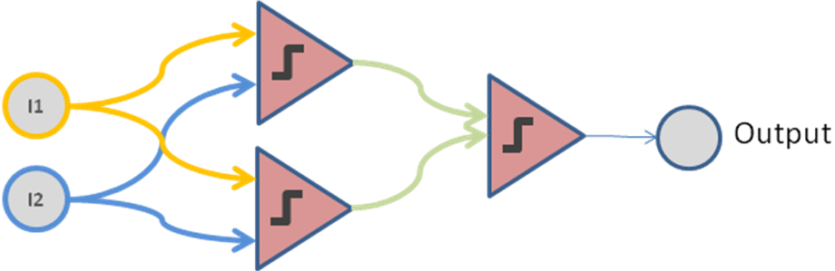
simple 3 neuron network

I1 | I2 | Expected | Actual
0 | 0 | 0 | 0
0 | 0 | 1 | 0
1 | 1 | 1 | 1
1 | 1 | 0 | 1

Simple fitness test score 1 for each output for a given input, so in the above 2 entries matche so the score is 2.

print $RND(18,-5,5) 'create 2 parent random weighted networks

Now that was very simple and could have been done as a straight calculation , so lets now build as 3 layer network!

for i=0 to 3
a=i%2
b=(i/2)%2
e=(a+b)%2
print "I1=";a;" I2=";b;" Expected=";e
next i

TBC

Using JBASIC pre-processor
Key advantages of the pre-processor
- enable programs to be stored on PC and transferred to robot when required
- auto generates line numbers (in increments of 5)
- allows comments to be added (using ' )
- allows labels
- allows multi-line if/then/else/endif statements
- allows const definition
Example file: test.rbas
'
' comments make more readable
'
const Del 50 '50 ms delay

loop:
A=A+1 ' notice LET is defaulted
PRINT "Test";a
WAIT Del
goto Loop
Invoke jbasic: java -jar JBasic.jar test.rbas this can be alias to jbasic to make it easier to type.
phil@phil-linux:~$ jbasic test.rbas
Compile test.rbas

-----Output-----
5 LET A=A+1
8 PRINT "Test";a
11 WAIT 50
14 GOTO 5
-----------
Constant defined
DEL 50
-----------
Labels defined
LOOP 5

0000 - AA 03 00 05 00 00 00 00 00 0F 00 41 2B 31 00 08 00 06 00 00 00 20 00 22
0018 - 54 65 73 74 22 3B 41 00 0B 00 0C 00 32 00 29 00 00 0E 00 05 00 05 00 32
0030 - 00 00 CC 00 00 00 00 00 00 00 00 00 00 00 00 00 00 00 00 00 00 00 00 00
This will have created a bindata.txt - which can be loaded into Basic(Remote) using z option or we can transfer to RBC running Basic firmware using -X option
Example of Basic code:
' Simple balance using ankle servos (2 & 7)
'
STAND $NS
LET K=2
LET G=$Z 'calibrate
PRINT "Press a key when ready: "; $kbd

loop:
LET D=G-$Z 'diff
PRINT D

IF D>10 then
LET T=K
ENDIF

IF D<(-10) then
LET T=(-K)
END IF

SERVO 2=$SERVO(2)+T
SERVO 7=$SERVO(7)-T

WAIT 50
GOTO loop

Working with BASIC (remote)
When a program is compiled a file bindata.txt is created - and this file can then be loaded into basic using 'z' option. It will also be automatically loaded into basic when it starts.
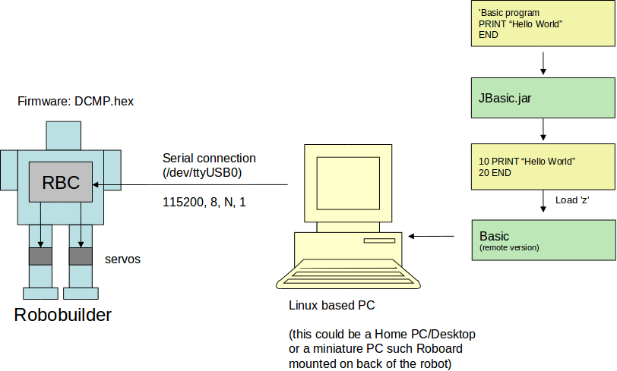

Example session
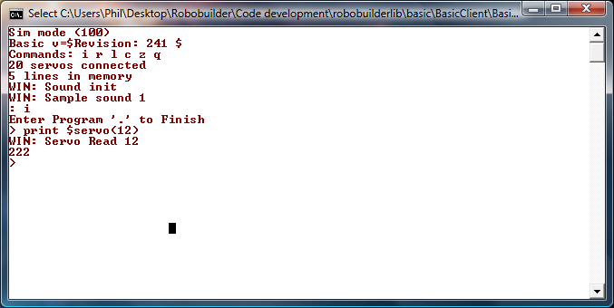
Figure 2

A’mazing
In the Robobuilder C programming tutorial there is an application written in C to enable the robot to traverse a maze using the distance sensor. You have to compile it in AVR C and download to the RBC. To make this easier to do, I've converted it to BASIC using the IDE.
The code builds uses the distance sensor to identify the walls and then the following algorithm:
1. If there is no wall, move forward.
2. If the wall is detected, then check left side.
3. If front and left side wall are detected, then check right side.
4. If front, left and right side walls are detected, go back the opposite way.
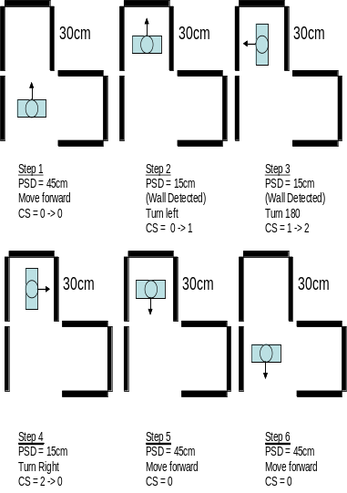
Figure 4

'example maze demo  const dly 1000  STAND 16  PRINT "Maze Program"  LET C=0  loop:  LET D=$PSD  LIGHTS d-10  IF D < 12 THEN  GOSUB back  GOTO loop  ENDIF  IF (c = 0) & (d < 30) THEN  GOSUB leftturn90  LET c=1  GOTO loop  ENDIF  IF (c = 1) & (d < 30) THEN  GOSUB leftturn180  LET c=2  GOTO loop  ENDIF  IF (c = 1) & (d < 30) THEN  GOSUB rightturn90  LET c=0  GOTO loop  ENDIF  LET C=0  GOSUB forward  GOTO loop | back:  PRINT ":"  RUN 9  WAIT 1000  RETURN  leftturn90:  PRINT "<-"  RUN 4  RUN 4  RUN 4  WAIT dly  RETURN  leftturn180:  PRINT "V"  RUN 4  RUN 4  RUN 4  RUN 4  RUN 4  WAIT dly  RETURN  rightturn90:  PRINT "->"  RUN 5  RUN 5  RUN 5  RUN 5  WAIT dly  RETURN  forward:  PRINT "^"  RUN 8  RUN 8  RUN 8  WAIT dly  RETURN
Example using Jbasic

'

Getting better output
The maze program is all very well but why not record the state of each cell the robot visits and build an internal map. To do this we can use the current array as a simple matrix, where the value of the matrix cell represents the state of the maze. So this can be unknown '*' or may be the direction the robot is pointing or if it detected a barrier/wall. Each iteration we then display the matrix by first clearing the screen.

Assuming you're connected on a standard VT100 terminal this is normally achieved by sending the sequence “Esc[2J”. Esc is ACSII value 27.

Clear screen
OUT 27 'esc
OUT 91 '[
OUT 50 '2
OUT 74 'J

We can initialise the matrix to the unknown state (lets say represented by '0'. here's how to create an empty matrix and fill with zeros.:

delete *
for i=1 to v*v
insert 0,0
next i

> PRINT @!:8
0,0,0,0,0,0,0,0
0,0,0,0,0,0,0,0
0,0,0,0,0,0,0,0
0,0,0,0,0,0,0,0
0,0,0,0,1,0,0,0
0,0,0,0,0,0,0,0
0,0,0,0,0,0,0,0
0,0,0,0,0,0,0,0

And now to display the matrix as a 2D image @
FOR J=0 TO v-1
FOR I=0 TO v-1
m=@![(I*v)+J]
IF m=0 THEN
OUT `.
ENDIF
IF m=1 THEN
OUT `*
ENDIF
NEXT I
PRINT
NEXT J

........
........
........
........
....^...
........
........
........

Planning and execution
Building on the maze – we could get the robot to plan path and then follow it.

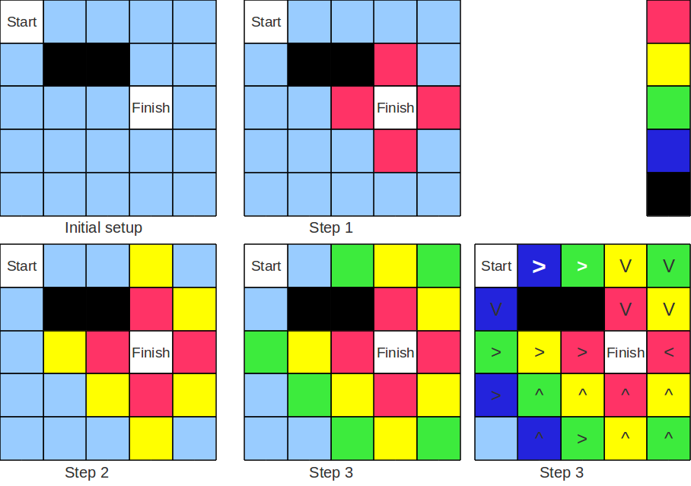

We first need to set up a matrix as was done in the Maze example by initialising the current list ! to contain a zero for each cell. So int eh above example a 5x5 matrix with 25 zeros. Then we place some hazards (shown in black) with a high negative score (or cost) and define a start and end point. The destination is given a high score – this is where we want to get to.

Initial Set up
To set two hazards we use the SET command i.e. SET 6,-500 and SET 7,-500, the destination is SET 13,100..

Step 1-n
We now calculate the cost of moving from one square to an adjacent square. This is done by comparing the cost of moving in each possible direction i.e. N,S,E or W and then choosing the maximum score. Thus if the “Finish” square has a cost of 100 then those adjacent will have a score 95. When doing the calculation the result must go into a separate array, now since we only have one the program insert the new element on the end of the current array. Thus the maximum size is a 64 array or 8x8 as the total size of the current array is maximum of 128 numbers. Its important to have a cost (in the code below 5) of moving from 1 square to the next this ensure the shortest path is chosen. Also the hazards having a negative score ensure the path flows away from them.

FOR I=0 to Y
FOR J=0 to X
m=@![(i*Y)+j]
c=m
IF J<7 THEN
t = @![((i+1)*Y)+j] - 5
IF m<t THEN
m=t
ENDIF
ENDIF

IF I>0 THEN
t = @![((i-1)*Y)+j] - 5
IF m<t THEN
m=t
ENDIF
ENDIF

IF J<7 THEN
t = @![(i*Y)+(j+1)] -5
IF m<t THEN
m=t
ENDIF
ENDIF

IF J>0 THEN
t = @![(i*Y)+(j-1)] -5
IF m<t THEN
m=t
ENDIF
endif

IF c>=0 THEN
insert $NE,m
ELSE
insert $NE,c
ENDIF

IF @![10]>0 THEN DONE
NEXT I
NEXT J

DONE:

We repeat the process by first transferring the new array into the start position (using DELETE command) and then repeat until the “Start” square get a value greater than zero. In the above example the test @![10]>0 tells us we have a “Plan”

Output
We now know the “cost” of the path from “Start” to “Finish” and can plot the direction by simply going from the current square to the next adjacent square with a higher score. Here an example from a bigger array 8x8 starting from [2,2] and finishing at [6,5]. The length/cost of the path from 2,2 is 60

0, 0, 0, 65, 70, 75, 70, 65

0, 60, 65, 70, 75, 80, 75, 70

0,-500,-500,-500, 80, 85, 80, 75

65, 70,-500,-500, 85, 90, 85, 80

70, 75, 80, 85, 90, 95, 90, 85

75, 80, 85, 90, 95,100, 95, 90

70, 75, 80, 85, 90, 95, 90, 85

65, 70, 75, 80, 85, 90, 85, 80

. . V V V V V V

. > > > V V V V

V # # # V V V V

V V # # V V V V

V V V V V V V V

> > > > > O < <

^ ^ ^ ^ ^ ^ ^ ^

^ ^ ^ ^ ^ ^ ^ ^

Notice although the “start” was 2,2 all the points in between also direct the robot to the finish. Its rather like water flowing from 2,2 until it goes down the “plug hole” at 6,5.

Building your own input line processing
Let create our own serial protocol to the RBC. To start we must define the protocol. So for example the input line must start with a # followed by a command, 'T' for test or 'S' for set servo and a set of numbers (showny by XX and YYY) I.e.
#tXXYYY test output values XX and YYY
#sXXYYY set servo XX to position YYY
Each character is read by $KBD which waits for input. And K will be assigned the ASCII value type is 65 for 'A'
This is what the program looks like
loop:
k=$kbd
out k
if k=`# then
a=$kbd
b=$kbd-48
b=b*10
b=b+($kbd-48)
c=$kbd-48
c=c*10
c=c+($kbd-48)
c=c*10
c=c+($kbd-48)

if a=`t then
print "Test ";b;",";c
endif

if a=`s then
print "Set servo ";b;"=";c
servo b=c
endif
endif

eol:
if k=7 then done
if k=13 then loop
k=$kbd
out k
goto eol

done:
print "Exit"
end

Performance and Debugging
Commands enable the debugging and performance of the code to be analysed. Overall BASIC is currently capable of running about 10,000 instruction per second (depending on complexity).

5 DATA A = 10,13,15,11,10,10,13,15,11,10,22,1,9,22,1,9
10 DATA B = 122,166,210,92,107,129,83,42,159,144,91,43,50,161,209,205
15 DATA C = 0,2,8,5,0,15,2,8,6,15,5,11,5,5,5,5
20 FOR X = 0 TO 15
25 FOR Y = 0 TO 15
30 LET P = $SIN((X+@C[Y])*16)/32
35 LET P = (@A[Y]*P)/1024
40 LET P = @B[Y]+P
45 PRINT P;":";
50 NEXT Y
55 PRINT ""
60 NEXT X
65 IF $KIR<0 THEN 20

‘R’ – Trace option
This enable the running a program one line a time. Before each line is executed BASIC will display the line number and command about to be performed and then wait for a key press. If the user presses ‘Escape’ key – the program will stop immediately displaying “**user break”. If the command is executed and it changes a variable (i.e. LET command) then the new value of the variable is displayed. See example below.

: R
Run Program
TRACE :: 5 - DATA
TRACE :: 10 - DATA
TRACE :: 15 - DATA
TRACE :: 20 - FOR
X = 0
TRACE :: 25 - FOR
Y = 0
TRACE :: 30 - LET
P = 0
TRACE :: 35 - LET
P = 0
TRACE :: 40 - LET
P = 122
TRACE :: 45 - PRINT
122:TRACE :: 50 - NEXT ** User Break
:

‘I’ – Timed execution of single command
: I
Enter Program '.' to Finish
> PRINT "hello"
hello
Elapsed Time 1ms
> PRINT $SIN(100)
20159
Elapsed Time 1ms
>

‘r’ – Timed execution
The run command its self can be used as it displays the elapsed time of the program. Here are 4 examples:

Example 1
> 10 FOR I=1 TO 1000
> 20 NEXT I
: r
Run Program
Elapsed Time 102ms

Example 2
> 10 FOR I=1 TO 1000
> 20 LET A=1
> 30 NEXT I
: r
Run Program
Elapsed Time 187ms

Example 3
> 10 FOR I=1 TO 1000
> 20 LET A=I
> 30 NEXT I
: r
Run Program
Elapsed Time 186ms

Example 4
> 10 FOR I=1 TO 1000
> 20 LET A=I*4+I
> 30 NEXT I
: r
Run Program
Elapsed Time 226ms

In example 1 – an empty for loop is executed 1000 time in 102ms. After the FOR performs initial setup, the NEXT instruction is the only command involved and is able to increment and conditional jump in 0.1 ms.

In example 2 – as simple LET command is added, now two command are executed 1000 times in 187ms or 0.09ms per instruction. The let instruction is only setting a constant value.

In example 3 – as example 2 but the LET expression now retrieves a value from another variable – but this no impact on execution time

In example 4 – the LET expression is made more complex. Doing 2 mathematical operations and this increases the time to 226ms or an extra 0.04 ms

Concluding Remarks

- BASIC.hex and Wiki information is available from http://code.google.com/p/robobuilderlib/

- Code examples are available from http://code.google.com/p/robobuilderlib/source/browse/#svn/trunk/examples

- Known bugs: (as of V375)

  - Mathematical expression of more than 5 operations will crash the program due to untrapped stack/memory problems

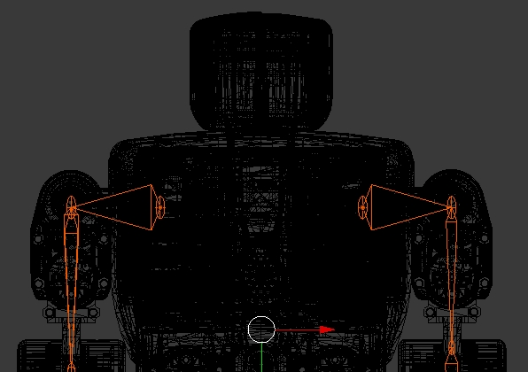

Appendix A – Language Specification
Language Spec:
VAR A-Z (integer only)
OPER + - * \ ( ) = < > % <= >= <> & |
CMD LET:FOR:NEXT:GOTO:IF:THEN:ELSE:PRINT:END:SET:RUN:POKE
WAIT:STEP:PUT:SERVO:MOVE:GOSUB:RETURN:LIST:STAND:OUT
I2CI:I2CO:OFFSET:SPEED:MTYPE
STRING " ... "
EXPR1 VAR | LITERAL
EXPR2 EXPR1 | STRING
LIST EXPR2 [,EXPR2]
EXPR EXPR1 OPER EXPR1
SYNTAX:
[LINE no] LET VAR '=' EXPR
[LINE no] GOTO [Line No]
[LINE no] PRINT LIST [;]
[LINE No] END
[LINE no] IF EXPR THEN LINE no ELSE Line No
[LINE No] FOR VAR '=' EXPR 'To' EXPR
[LINE No] NEXT VAR
[LINE No] WAIT number
[Line No] SERVO ID=EXPR | '@' | '~'
[LINE No] LIST [VAR]=N,1,2,3 ..
[LINE No] DATA [VAR]=1,2,3 ..
[LINE No] MOVE @[VAR],100,20
[Line No] GOSUB [Line No]
[Line No] RETURN
[Line No] STAND [16 | 18]
[Line No] POKE number,number
[LINE No] PUT VAR '=' $PORTA|B|C:0-7
[LINE No] OUT EXPR,EXPR
[Line No] RUN number
[Line No] PLAY number
[Line No] OFFSET [# | List | "blank"]
[Line No] IC2O number,List
[Line No] IC2I number,number,List
[Line No] SPEED number
[Line No] MTYPE number,number,List
[Line No] STEP ID=number,number,number
[Line No] SAMPLE a,b[,c[,d]]
[Line No] FFT list,scale
[Line No] SCALE list,scale
[Line No] GET
[Line No] SET index,value
[Line No] SORT @array | SORT #a,b,c
[Line No] INSERT index,value
[Line No] DELETE index
[Line No] SELECT index,index
[Line No] GEN No_Gn,length,Mute rate%,Mute rnge,Val[min,max]
[Line No] NETWORK - new tbc

Command | Description
SERVO ID=POS | set servo id to position POS / @ / ~
LIST A=3,1,2,3 | Create a list – in this case @A is a 3 element list 1,2,3
MOVE @A,t,f | sends a Scene - 'n' Servo Positions, Plus time, no frames
POKE 10,A | Put A into Byte 10
PUT PORT:A:8 = 3 | set DDR of Port A = 3 (PIN0,PIN1 readable)
PUT PORT:A:2 = 1 | set Port A bit 2 =1 (assuming writeable)
WAIT 200 | Wait for a an amount of time in ms i.e. 200ms
STAND 16 | set servos to basic posture (for 16 or 18 servo bots)
OFFSET | Defines a numeric offset array to be applied to MOVE and PLAY commands
I2CO 51,@{3,1,2,3} | will send 3 bytes to I2C address 51
I2CI 52,5,@{2,1,1} | will read 5 bytes from address 52 after first send 2 bytes (1,1) to the same address.
SPEED 2 | Speed torque setting on Move 0-4 (0 maximum, 4 minimum)
MTYPE 3 | Set Motion type 0: Acc, 1=Deacc, 2=AccDeacc, 3=Linear
STEP 5=30,50,5 | STEP servo 5 from position 30 to position 50 in increments of 5 checking progress and stopping if obstruction
RUN 0 | Call Built in action using code i.e. RUN 0, would punch left  Built in motions:
RUN 0 | 0) PunchLeft  1) PunchRight  2) SidewalkLeft  3) SidewalkRight  4) TurnLeft  5) TurnRight  6) GetupBack  7) GetupFront  8) WalkForward  9) WalkBackward | 10)lshoot  11)rshoot  12)rsidewalk  13)lsidewalk  14)standupr  15)standupf  16)sitdown  17)hi  18)kick left front turn
LIGHT n[,@list] | Show value ‘n’ in LIGHTS
SORT @List | Sort list numerical ascending
FFT @List,scale | FFT @list (scale to value)
SAMPLE a,b[,c[,d]] | A= trigger level, b=timeout value in ms, c= sample rate, d samples (64 is max)
SCALE @list,scale | Scale list to maximum (pk) value
Expressions can include “Special Registers” i.e LET A=$X+5 would set variable A to the current value of the X axis of the accelerometer plus 5.
Special register access ($) | Description
$X, $Y, $Z | accelerometer values
$IR | wait for IR remote and get button pressed LET A=$IR
$KBD | wait for keyboard press
$KIR | Scan keyboard and IR port return immediate -1 if nothing pressed
$PSD | PSD sensor value
$VOLT | Battery voltage
$TICK | Number of tenths of a second
$PORT | Read Bit 6 of Port A .. LET A=$PORT:A:6
$RND | Random numbers - different number each time called
$MIC | Microphone level
$SERVO(id) | Read position of servo id, i.e. LET A=$SERVO(5) gets Servo ID 5 position . If no parameter supplied $SERVO will scan all servos returning the number connected (and loads the positions into the special @? List)
$ABS(x) | Absolute value of x returned
$ROM(x) | Contents of ROM location x, i.e. LET A=$ROM(10)
$FIND(x, @A) | Look for item less than or equal to X and return index
$CVB2I(x) | Converts byte to int, i.e. 4 -> 4 and 254 -> -2
$NE | Number of elements in a list
$NS | Number of servos detected
$MAX / $IMAX(@A, N) | $MAX element (or index of) in list from position N
$SUM(@a) | Sum of elements
$NORM(@a) | Normal of a list a (square root of sum of the squares of the elements of the list)
$MIN(@a) | $MIN element in list
$SQRT(x) | Integer Square root of x 25 -> 5
$SIN(a) | The integer SIN of angle a – (0-255) represent 0-2Pi result ranges between +32,768 and -32,767 (representing +1.0/-1.0)
$COS(a) | COS (see above
$HAM(x,@a,@b) | Calculate Hamming distance (between a and b) return integer 0 to Number Elements
$RANGE(a,b,c) | Return a, unless a<b in which case return b, or a>c in which case c. So the value returned is always between b( minimum) and c (maximum)
$MAPIR(x) | Maps value from IR to built in action code (i.e. 8 -> 3 )
$SIG(x,n?) | SIGMOID(x) - different scaling options set by n
$ZEROS(x) | returns an array of zeros
$STAND(x) | )return an array of positions related to stand$
$DSIG(x) | SIGMOID derivative i.e. returns x(1-x)
 | IR value  1 A  2 B  3 LeftTurn  4 Forward  5 RightTurn  6 Left  7 Stop  8 Right  9 Punch_Left  10 Back  11 Punch_Right  12 N1  13 N2  14 N3  15 N4  16 N5  17 N6  18 N7  19 N8  20 N9  21 N0 | Builtin Motion:  7 GetUp Front  6 Get Up Back  4 Turn Left  8  5  2  17  3  0  9  1  10  11  12  13  14  15  16  18  19
Bottom of Form

